# **How to use the “Terrain to Island” thing:**

# This tool is from the Fall 2019 INFO6028 “Graphics 1” Mid-term Exam.

There’s a PowerPoint that (sort of) explains how it works.

Basically, it takes the “fractal terrain” from MeshLab (or any 256x256 grid, I suppose) and makes something that sort of looks like an island from a low poly game.

1. (5 marks) Using MeshLab, generate a SINGLE island, in the following way:

* Open MeshLab (without opening a model). This will open it with an empty “project”
* Choose “Filters”, then “Create New Mesh Layer”, then “Fractal Terrain”
* In the “Fractal Terrain” dialog box, choose “**Hybrid multifractal terrain**” (“Algorithm” dropbox.)
* Change the “Max Height” to **0.5**.
* Pick a “Seed” value (the default is 2.0)
* ***For the 2019 Mid-term, I had the students do this:***
  + Get the ASCII value for each letter of your *full* name. Add all these numbers up. Take the first three (3) numbers of the final result as your seed value.
  + For example: **Michael Feeney** gives: 77+105+99+104+97+101+108+ (“Michael”)  
    70+101+101+110+101+121 (“Feeney”)  
    = 1295 🡪 *so my seed would be “129”*

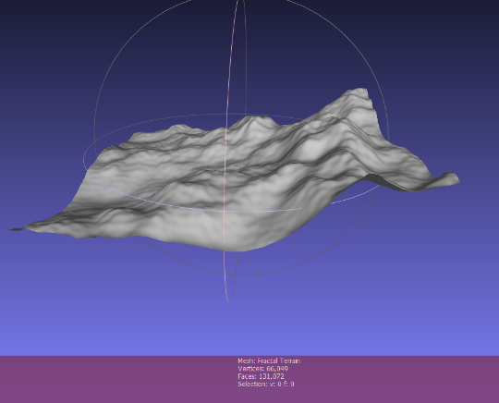

* + Note: It seems that really large numbers, like your 8 digit student number, make the terrain ‘blocky’

With a “Seed” value of 2.0, you will get this 🡪

The Island Converter assumes “up” is “z”, so we need to adjust this. Turn on the “axis” drawing by choosing “Render”, “Show Axis” to make this clear (if you want).

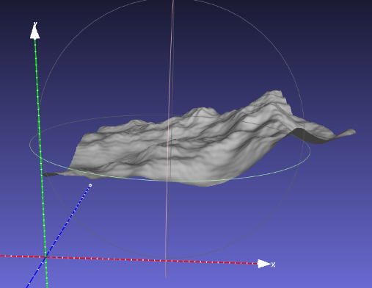

* Choose “Filters”, “Normals, Curvature, and Orientation”, then “Transform: Rotate”.
* Type in “-90” in the “Rotation Angle”, leaving the “Rotation on:” set to “X axis”, and click “Apply”, which will get you this 🡪
* Save this model with JUST xyz and NOT in binary form (“File”, “Export Mesh As…”, uncheck the “Binary encoding”, and choose OK.
* Download and compile the “Terrain_to_Island_Converter” project and convert the mesh you made into an island. This takes the model file name as an input and generate an “island” mesh (like the one on the right 🡪) called “output.ply”.

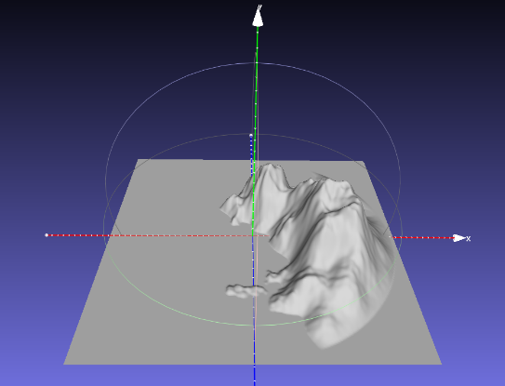

* Open this model into mesh lab, generate normals and scale it by 2.0:
  + Choose “Filters”, “Normals, Curvature, and Orientation”, then “Re-Compute Vertex Normals”
  + Choose “Filters”, “Normals, Curvature, and Orientation”, then “Transform: Scale, Normalize ”; type in 2 in the “X Axis” text box;   
    Click “Apply”
  + Save the model (BE SURE TO SAVE *WITH* NORMALS)
* You will use this model as the island your pirates live on.   
  The model should be:
  + 512 units wide in the XY axis, from -256.0 to +256
  + The “water” should be at 0.0 along the y axis.
  + The maximum height should be something like 150 (but will depend on the seed value)

NOTE: If your code requires texture coordinates, you can generate ones in MeshLab like this:

* Choose “Filters,”
* then “Textures”,
* then “Parameterization: Flat Plane”
* Choose “XY” as the “Projection Plane”
* Click “Apply”
* Next, convert to “per vertex” texture coordinates:
* Choose “Filters”,
* then “Texture”,
* then “Convert PerWedge UV to PerVertex UV”
* When you save it, be sure to *un*-check the texture coordinates in “Wedge” and *check* the one in “Vertex”